Alexander Munoz

CSE 179

19 March 2020

Lab 6

**Task 1.1**

*See attached MPI_collective.c

Set processes to 4

Output:

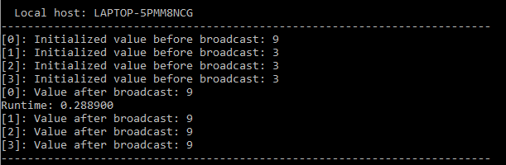

Set processes to 6

Output:

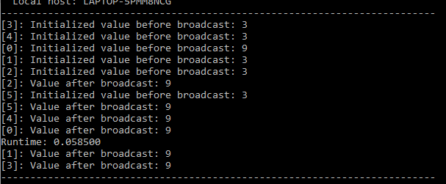

Set processes to 8

Output:

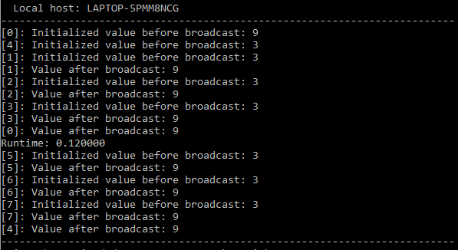

**Task 1.2**

*See attached MPI_scatterGather.c

Set processes to 4

Output:

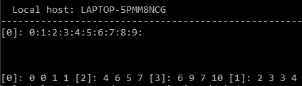

Set processes to 6

Output

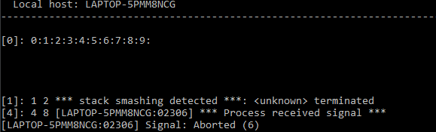

Set processes to 8

Output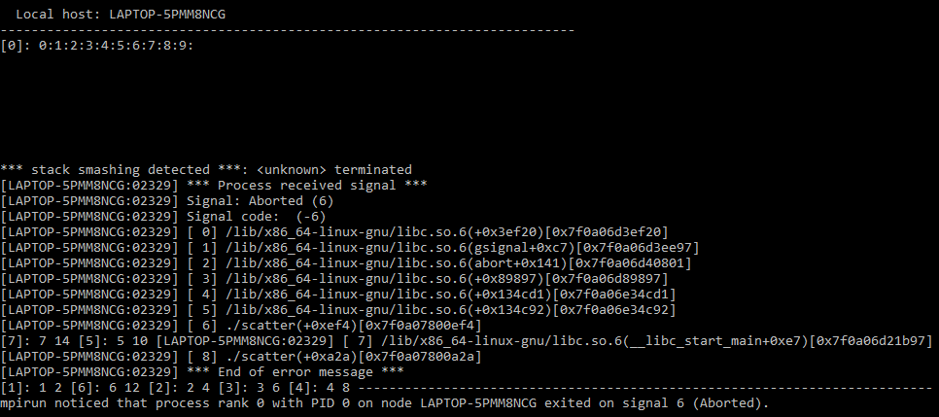

Could not fully understand or figure out task 2 or 3

**Task 2**

*See attached

Output:

**Task 3**